**SQT Project**

|  |  |
| --- | --- |
| **Names of student** | **ID** |
| Uddin Minhaz | 15-28816-1 |
| Jahin, ashadul Hoque | 15-28980-1 |
| Islam Raisul | 15-28950-1 |

**Submitted By:**

**Section: B**

**Submitted To:**

MD. SHAMSUR RAHIM

Test Report

Software tests have to be repeated often during development cycles to ensure quality. Every time source code is modified in software, so tests should be repeated. Manually repeating these tests is costly and time consuming. Therefore, we use automation for testing.

**In our project we tried to cover 47% automation testing using sikuli testing tool.**

It is not possible to test the User Experience and User Interface through the automation testing. Changes in these can only be detected and done by manual testing, which means that not all testing can be done with automatic tools. So for our Microsoft word testing project we did almost all the testing manually

**In our project we tried to cover 53% manually testing.**

Our project is about to test a desktop application (Microsoft word 2010).We write 100 test cases about different functionality of Microsoft word.

**In this project almost 99.99% test cases are passed. We checked all the test cases several times.**

**Column chart representation (Test case Pass-99% & Fail-1%):**

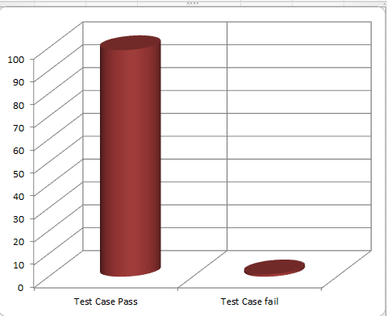

Figure-01: **Column chart**

**Pie chart representation (Automation Test & Manual Test):**

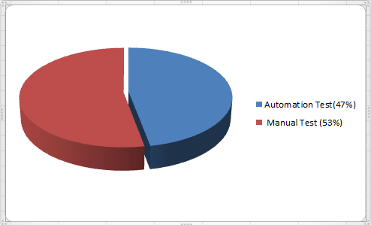

Figure-02: **Pie chart**